**Use of Artificial Neural Networks to Identify Fake Profiles**

In this paper using Artificial Neural Networks we are identifying whether given account details are from genuine or fake users. ANN algorithm will be trained with all previous users fake and genuine account data and then whenever we gave new test data then that ANN train model will be applied on new test data to identify whether given new account details are from genuine or fake users.

Online social networks such as Facebook or Twitter contains users details and some malicious users will hack social network database to steal or breach users information, To protect users data we are using ANN Algorithm.

To train ANN algorithm we are using below details from social networks

**Account_Age, Gender, User_Age, Link_Desc, Status_Count, Friend_Count, Location, Location_IP, Status**

All fake users main intention is to send friend request to normal users to hack their machine or to steal their data and never they will have many number of posts or have many following friends and their account age also will have less number of years. By analysing this features Facebook will mark whether user profile is fake or genuine. This Facebook profile data we downloaded from Facebook website and using this data to train ANN model. Below are some values from profile dataset.

**Account_Age, Gender, User_Age, Link_Desc, Status_Count, Friend_Count, Location, Location_IP, Status**

10, 1, 22, 0, 1073, 237, 0, 0, 0

10, 0, 33, 0, 127, 152, 0, 0, 0

10, 1, 46, 0, 1601, 405, 0, 0, 0

10, 0, 25, 0, 704, 380, 0, 0, 0

7, 1, 34, 1, 64, 721, 1, 1, 1

7, 1, 30, 1, 69, 587, 1, 1, 1

7, 1, 36, 1, 61, 782, 1, 1, 1

7, 1, 52, 1, 96, 827, 1, 1, 1

In above dataset all bold names are the dataset column names and all integer values are the dataset values. As ANN will not take string value so we convert gender values to 0 or 1, if male value is 1 and if female value is 0. In above dataset last column give us information of fake or genuine account if last column contains value 0 then account is genuine otherwise fake. All fake account will have less number of posts as their main intention is to send friend requests not posts, so by analysing this features Facebook mark that record with value 1 which means it’s a fake account. We are using above dataset to train ANN model and this dataset saved inside code ‘dataset’ folder. After building train model we input test data with account details and ANN will give result as fake or genuine. Below are some values from test data

**Account_Age, Gender, User_Age, Link_Desc, Status_Count, Friend_Count, Location, Location_IP**

10, 1, 44, 0, 280, 1273, 0, 0

10, 0, 54, 0, 5237, 241, 0, 0

7, 0, 42, 1, 57, 631, 1, 1

7, 1, 56, 1, 66, 623, 1, 1

In above test data STATUS column and its value is there and ANN will predict status and give us result whether above test data is fake or genuine. In output we can see result of above test data.

**ANN algorithms Details**

To demonstrate how to build a ANN neural network based image classifier, we shall build a 6 layer neural network that will identify and separate one image from other. This network that we shall build is a very small network that we can run on a CPU as well. Traditional neural networks that are very good at doing image classification have many more parameters and take a lot of time if trained on normal CPU. However, our objective is to show how to build a real-world convolutional neural network using TENSORFLOW.

Neural Networks are essentially mathematical models to solve an optimization problem. They are made of neurons, the basic computation unit of neural networks. A neuron takes an input (say x), do some computation on it (say: multiply it with a variable w and adds another variable b) to produce a value (say; z= wx + b). This value is passed to a non-linear function called activation function (f) to produce the final output (activation) of a neuron. There are many kinds of activation functions. One of the popular activation function is Sigmoid. The neuron which uses sigmoid function as an activation function will be called sigmoid neuron. Depending on the activation functions, neurons are named and there are many kinds of them like RELU, TanH.

If you stack neurons in a single line, it’s called a layer; which is the next building block of neural networks. See below image with layers

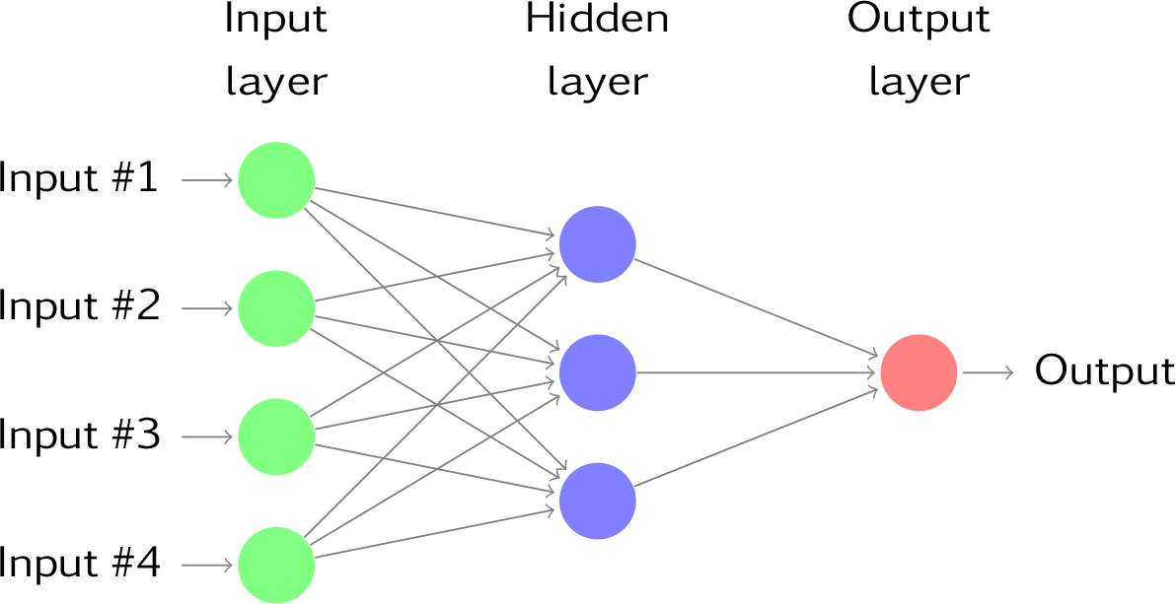

To predict image class multiple layers operate on each other to get best match layer and this process continues till no more improvement left.

Module Details:

Admin Module: Admin will login to application by using username as ‘admin’ and password as ‘admin’ and then perform below actions.

1. Generate ANN Train Model: Admin will upload profile dataset to ANN algorithm to build train model. This train model can be used to predict fake or genuine account by taking new account test data.
2. View ANN Train Dataset: Using this module admin can view all dataset used to train ANN model.

User Module: Any user can use this application and enter test data of new account and call ANN algorithm. ANN algorithm will take new test data and applied train model to predict whether given test data contains fake or genuine details.